Exercise 4-3-2 JavaScript Function

### 4-3-2 Write function with embedded scripts

Write the JavaScript codes in sum.html. Firstly, define a JavaScript function sum(n). The function calculates the sum of 1 to n. Then input a number n with function prompt. Then use function sum(n) to calculate the sum of 1 to n. Finally make the p element demo display the calculation the result of 1 to n.

**Requirement 1**: Use *for loop* statement to calculate the result in the function.

**Requirement 2**: Write JavaScript codes in <script> … </script>

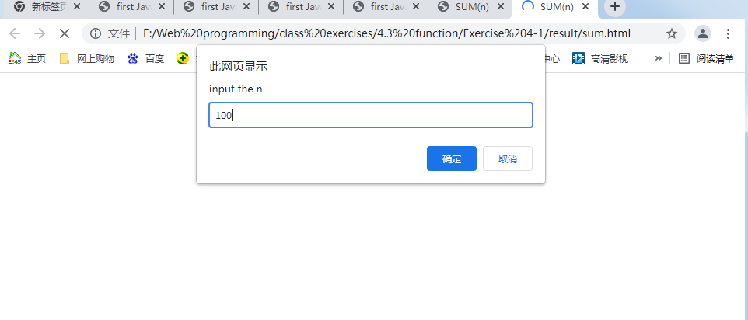

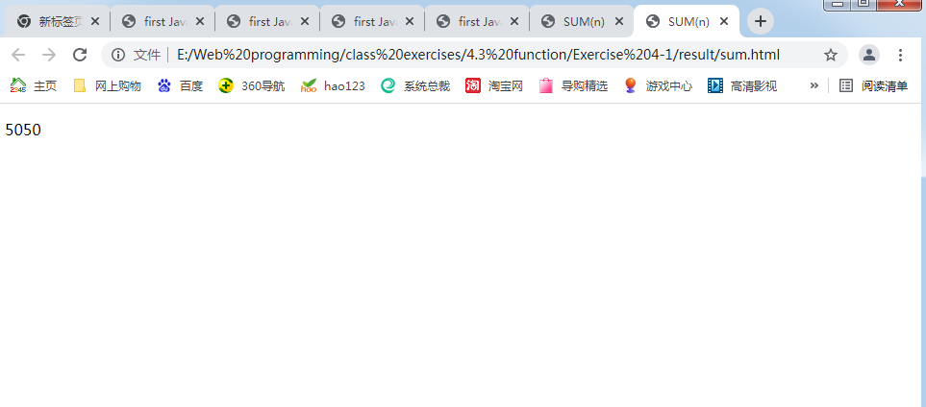

### 4-1-2 Write function with external scripts

Write the JavaScript codes in sum.html. Firstly, define a JavaScript function sum(n). The function calculates the sum of 1 to n. Then input a number n with function prompt. Then use function sum(n) to calculate the sum of 1 to n. Finally make the p element demo display the calculation the result of 1 to n.

**Requirement 1**: Use *for loop* statement to calculate the result in the function.

**Requirement 2**: Write JavaScript codes in JS file *sum.js*.